***Internship***

* 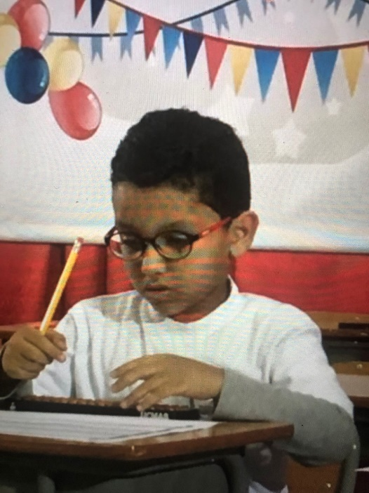Hello, my name is Nadeem Hani Shaaban, and I am 14 years old. I am in year 9. My ambition is to pursue a career in information technology, I live in Kuwait, and I would love to become a computer programmer.
* I have created my project for people who want to try cooking for the first time and need short and direct instructions to make delicious and extremely simple recipes.
* I’ve used Python and Jupiter notebook to make this project, I also used tkinter for the program itself so that the client can type in the commands himself and get the bot’s answer.

